Evergreen Special Issue Proposal Form

Please fill in the following information and send back to the Executive Editor (kyaw.thu.813@m.kyushu-u.ac.jp) with a carbon-copy to the Evergreen Secretariat (evergreen@ga.kyushu-u.ac.jp).

- Introduction: (Please provide a short description of the event such as conference for the special issue)
Enter your information here.
- Scope: (Please provide a short scope of the event such as conference for the special issue)
Enter your information here.

- Participants: (Please provide an estimated participants of the event)
Choose an item.
- Schedule and Location: (Please provide dates and venue of the event)
Enter the information here.
- List of Journals for the Special Issue: (Please provide the arranged Journals including Evergreen)
Enter the infomation here.
- Expected number of Manuscripts in Evergreen: (Please provide the estimated numbers)
Choose an item.
- Expected web publication date: (Please provide a preferred date of announce on the event site)
9/19/2021
- Expected Issue in Evergreen: (Please provide a preferred Issue in Evergreen)
Volume: Enter the Volume number of Evergreen here.
Issue: Enter the issue number of Evergreen here.
- Managing guest editor: (Please provide the sole correspondent with whom Evergreen communicates)
Name: Type the name here.
Affiliation: Add the affiliation here.
Address: Add the address here.
Email: Add the email address here.
- Selection committee: (Please provide information of the selection committee for the special issue)
Please enter the text here. Note that the number of characters is limited.
- Guest Editorial Team: (Please provide information of the editorial team for the special Issue)
Please enter the information on the Guest Editorial team. Note that the number of characters is limited here.

Important Note:
The key objectives of arranging special issues in EVERGREEN are (1) to promote collaboration between researchers from conferences and EVERGREEN (IGSES, Kyushu University), and (2) contributions to EVERGREEN in terms of quality papers, review service and visibility of the journal.

Proposed APC per article: Choose an item.

☐ I/We have checked the procedures of the manuscripts for the special issues in Evergreen (APPENDIX) and agree to comply with it.

Signature & Date: | _________________________ | Click or tap to enter a date.
Name: | Enter the name of the managing guest editor
Affiliation: | Enter the affiliation here.
Address: | Enter the address here.

APPENDIX

Procedures of the manuscripts for the special issues in Evergreen

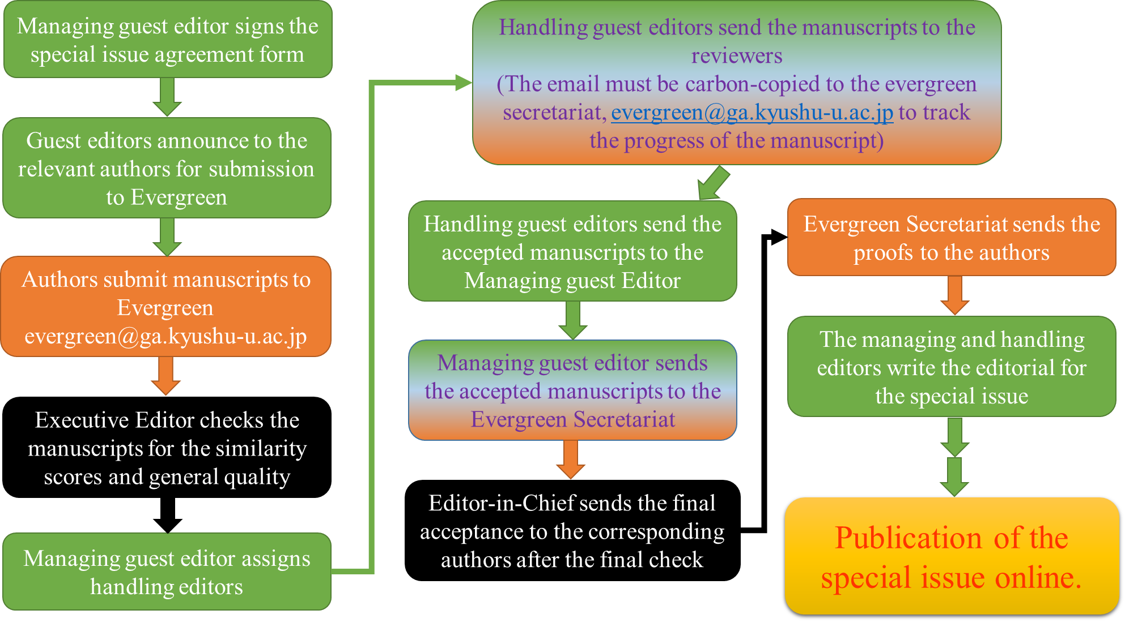
Note: The special issue agreement form with the terms will be duly sent upon the successful proposal for the special issue in Evergreen.

